# COMP3512 - Lab Exercise 1 (Sep 11 - 15, 2017)

This is an exercise that you need to do on a computer. You'll need to commit and push your code to your GitLab repo, and submit for automated marking via Slack.

On the first day at any company, you will be asked to install and setup multiple programs and accounts. At the end of the day, you should be able to build and test the existing codebase. For this exercise, you are asked to setup your environment that will be used for all the labs and assignments in this class.

## 0. Check the Privacy Info Sheet

It's on D2L under Table of Contents

## 1. Install Visual Studio 2017 on a Windows Machine

We use Visual Studio 2017(**NOT** Visual Studio Code) in this class. You all used gcc in COMP2510, and this is a good time to use the best C++ development tool in the industry. VS 2017 is already installed on your lab computer. If you are using your own computer, you will have to download and install it manually.

1. Installation link
   1. VS 2017 Community: <https://www.visualstudio.com/downloads/>   
        
      or
   2. VS 2017 Enterprise: <https://www.bcit.ca/its/software/>
2. While you are installing, make sure to check **Desktop development C++** workload as shown in the following video: [Video Link(2:30-5:30)](https://www.youtube.com/watch?v=39IsItNIoQs&feature=youtu.be&t=2m30s)

This might take a while, so once the installer starts to install VS 2017, go to the next steps.

## 

## 

## 2. GitLab Account Setup

For all the assignments and labs in this class, you are required to hand in your submission to your **PRIVATE** GitLab repository, which will be shared with only your instructor. ***Please note that if you become involved in any plagiarism case because your repository is public, you will be also liable.***

1. Go to <https://gitlab.com>
2. Click on Register link at the top right corner to create an account.
   1. Using fake name is completely fine (to save your privacy)
   2. Create it with username and password. If you use google login, you will have to set another password on GitLab again
3. Once your account is created and verified, you might have to login to gitlab again.
4. Once you login, click on New Project button
5. Once new page is open, enter your project name. Again feel free to use any fake project name to save your privacy
6. Make sure that Visibility Level is set to Private, and then click on Create Project  
   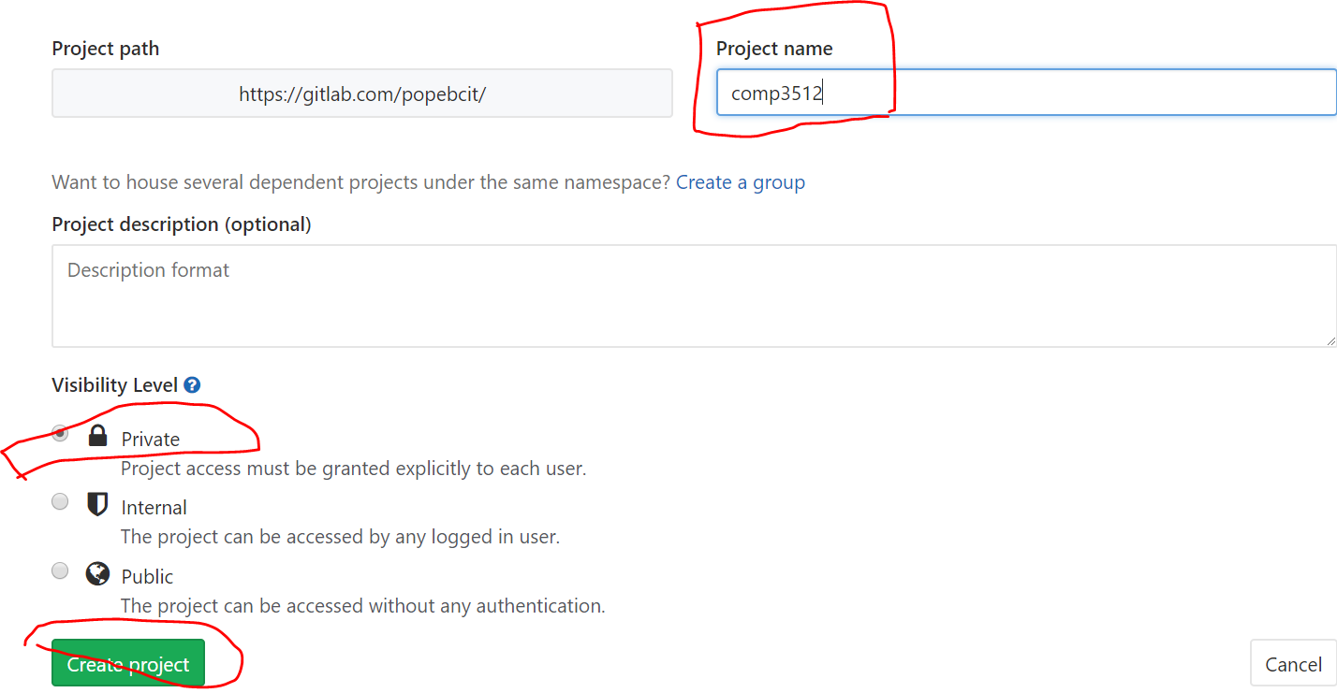
7. Once the new project is created, you will see your https repo address. Copy it somewhere. You will need it later  
   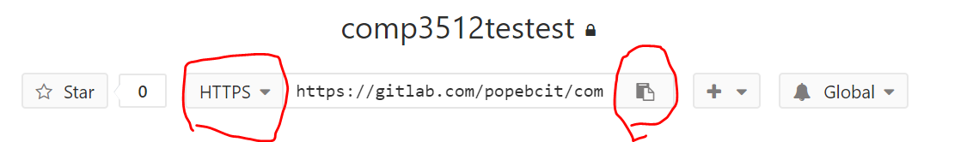
8. From the top menu, click on Members
9. Enter these information
   1. Select Members to Invite: popebcit
   2. Role Permission: Reporter
   3. Expiration Date: January 1st, 2018
10. Click on Add To Project

## 3. Join Slack

In this class, Slack is used as the default communication channel with instructor. Also this is where you submit your labs and assignments for grading.

1. Go to <https://comp3512-201709.slack.com>
2. Signup with your school email address (*@my.bcit.ca or *@bcit.ca)
3. Feel free to fake username and names to save your privacy. Just pick something that you like, but do **NOT** offend anyone.
4. There are also desktop and mobile apps for Slack. Installing them would make your life easier.

## 4. Register Yourself on AutoGrader Website

Your instructor has developed web services to automate the submission and marking processes. Please go to this website and register yourself. (Note: All the servers are located in Canada to comply with BCIT's privacy policy. Any student information will be deleted after this term ends)

Make sure all the information that you submit during registration is correct. (If any information is wrong, automated marking will not work.)

* <https://cppauto.azurewebsites.net/Account/Register>
* **When you enter slack username don't put @ in front of your username**

## 5. Install a Git Client

If you have not used Git, SourceTree is a recommended. If you know how to use git already, you are free to use any client that you want, but all instructions in this document are written for SourceTree.

* Download and Install Source from <https://www.sourcetreeapp.com/>

## 6. Getting Your Repo Ready

1. Open SourceTree
2. Click on Clone button
3. Paste your repo's HTTPS URL (you copied this at Step 2.g)
4. Optionally select a directory where you will save all your work
5. Press Clone
6. Open your file browser and go to the folder you just cloned. You should see an empty directory (or a hidden folder named .git)
7. Open a web browser and navigate to <https://github.com/popekim/CppTemplate>
8. Select Clone or Download > Download ZIP
9. Unzip the file contents to the directory created at Step 6.6. After this your folder should look like this. (all these files are at the root of your folder)  
     
   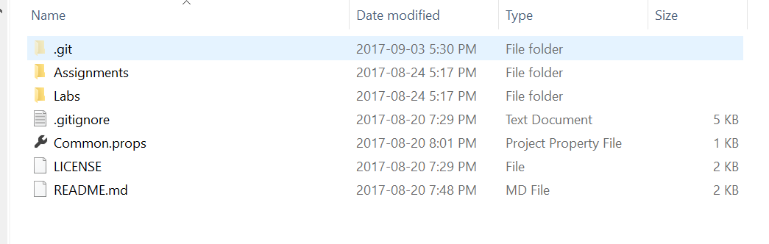
10. Go back to SourceTree. You will see a lot of unstaged files. Press Stage All button  
    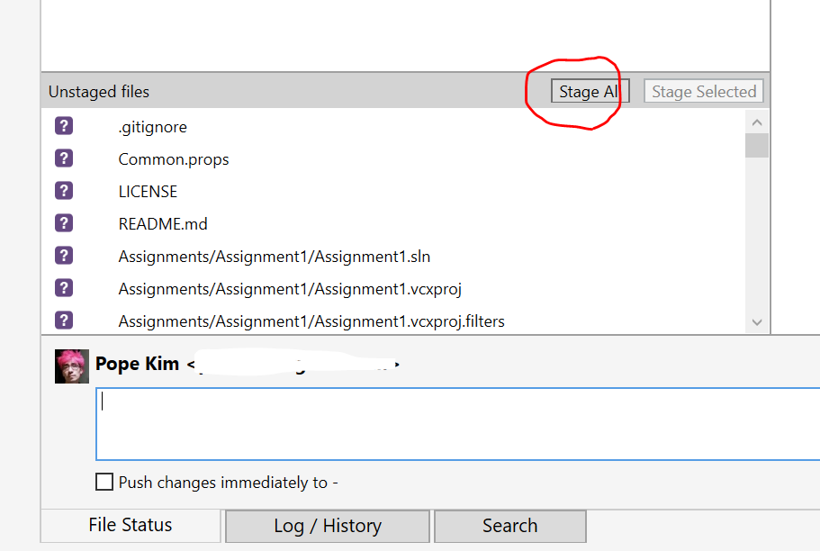
11. Enter some commit message(whatever you like), check the checkbox and press commit button  
    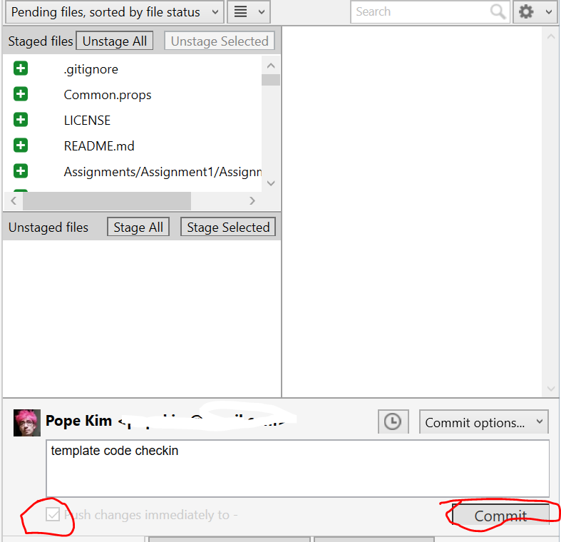

Step k and l are how you would submit your labs and assignments. But, don't worry. We will do it one more time in the next section.

## 

## 

## 7. Write a Simple Program

This is the testable and gradable part of your lab today. You must implement a function that adds two integers.

To make the automated grading work,

* You must have Add.h file
* Add.h file must have the following function in lab1 namespace (just copy and paste the code below)  
    
  #pragma once

namespace lab1

{

int Add(int a, int b);

}

Follow these steps to make this simple program

1. In your file browser, go to labs/lab1 folder
2. Double click on lab1.sln file to open it in Visual Studio 2017
3. Once the solution is open, find Solution Explorer  
   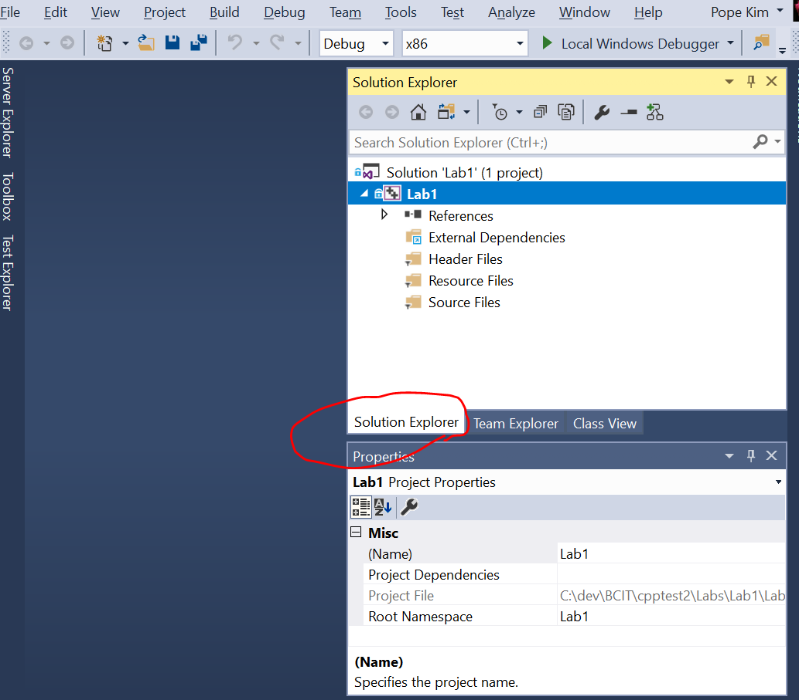
4. Right click on Project named Lab1 and select Add > New Item  
   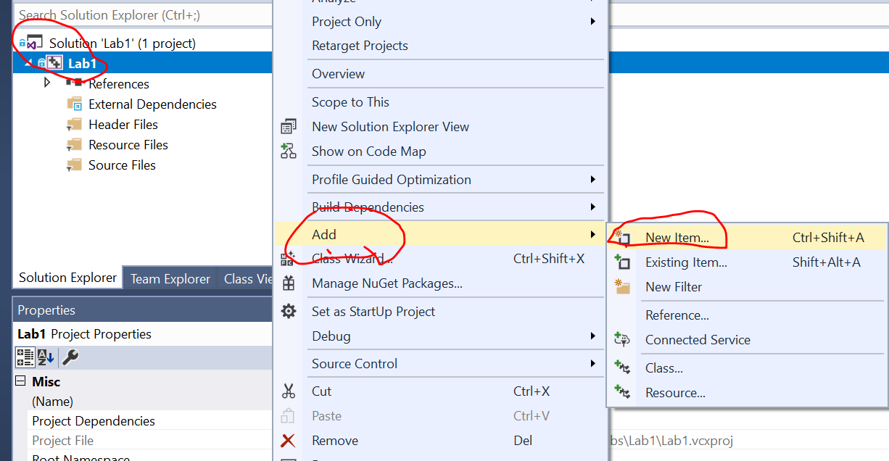
5. Select Visual C++ > Header File, and type Add.h for filename  
   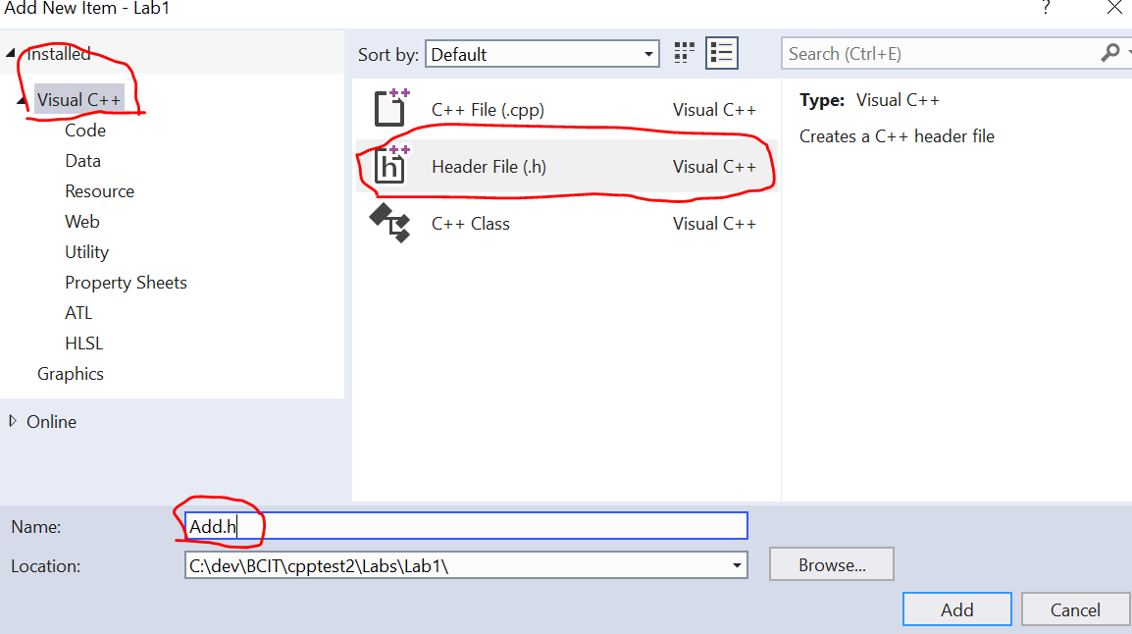
6. Press Add
7. Do the same steps to add Add.cpp and main.cpp, but this time please select C++ File (.cpp)
8. The Solution Explorer should look like this  
   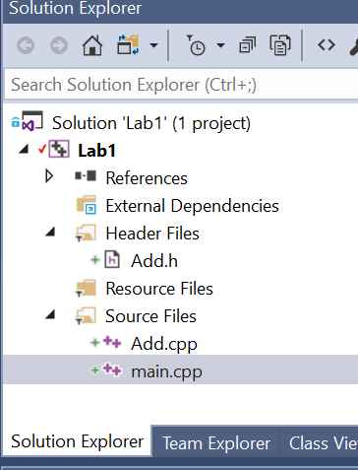
9. Double click on Add.h and paste the code given at the beginning of this section
10. Double click on Add.cpp to implement the function
11. Double click on main.cpp to implement the program entry point: int main(). Feel free to add any test code for your own debugging here
12. Once you think you are ready, go to the top menu to select Build > Build Solution. The output window will show up at the bottom. If there's any error or warnings, FIX IT and repeat this step.
13. Once compilation is done. Press F5 or  to run the program. It runs, but probably the console window will disappear right away.
14. To fix this issue, add a breakpoint at the end of the main function by clicking on the space left to the code line.  
    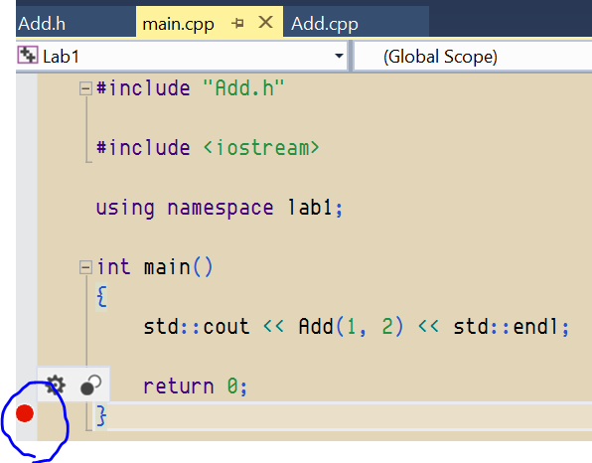
15. Rerun the program. And you should see the result. Press F5 or the play button again to continue the program (which exits right away)

Now you are ready to submit your code.

## 

## 

## 8. Submitting Your Code for Grade

1. Open SourceTree again. (and maybe press F5 to refresh your file status)  
   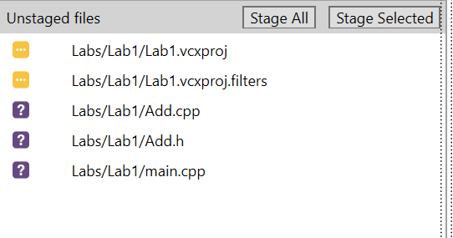
2. Press Stage All
3. Add commit message, check the checkbox and press Commit  
   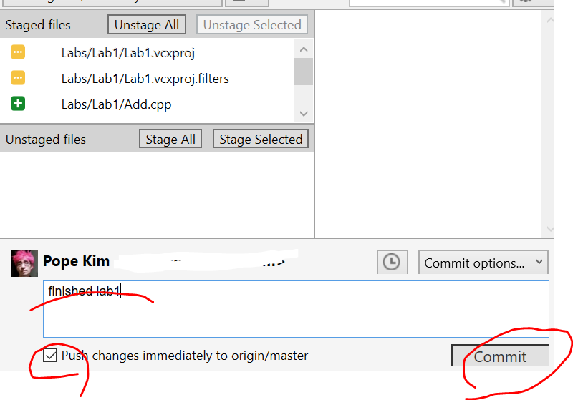
4. Open Slack
5. In any channel, enter this command. (This only opens during your labtime)  
     
   /build lab 1
6. Then Build Bot will start to process your lab.  
   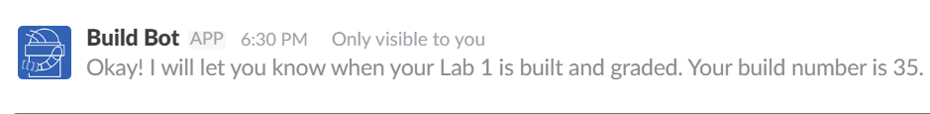
7. Wait for a couple of mins. Build Bot will send you a private message with the build result  
   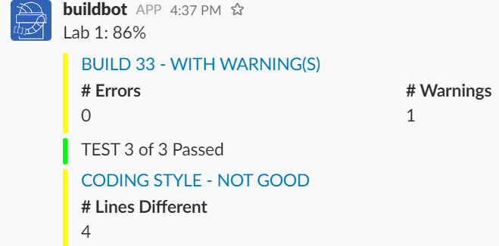
8. You can click on the links to find out more details on why you lost some marks. Fix them until you get to 100%.
9. If you get coding style errors. [Refer to Our Coding Standards](https://docs.google.com/document/d/1cT8EPgMXe0eopeHvwuFmbHG4TJr5kUmcovkr5irQZmo/edit)

Unless you get caught for plagiarism later, the mark you get from the Build Bot is your final mark for any given lab and assignment.

And you are done!